**ASSIGNMENT 33.2**

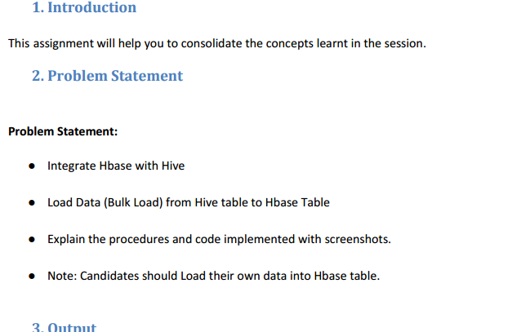

For setting up of hive with hbase integration, we require a few jar files to be present in /home/acadgild/hive-2.1.0-bin/lib directory. The required jar files are:

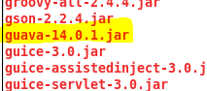

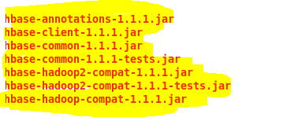



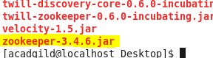

For setting up of hive with hbase integration, we require a few jar files to be present in /home/acadgild/hbase-1.0.3/lib directory. The required jar files are:

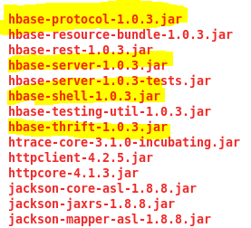

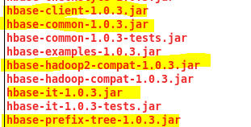

We need to add the paths of the above jar files to value of hive.aux.jars.path property in hive-site.xml configuration file



We create a new hbase table via hive shell. In this we are creating hbase_table_emp table in hive and emp table in hbase. this table will contain 3 columns in hive, key int, name string and role string. These are mapped to two columns : name and role belonging to cf1 column family. Here “key “is specified at the beginning of “hbase.columns.mapping” property which automatically maps to first column(id) in hive table

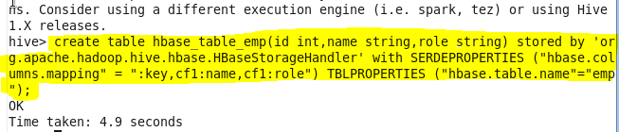

Verify this table in hbase

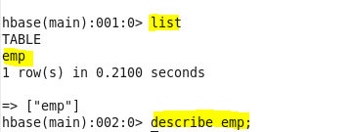

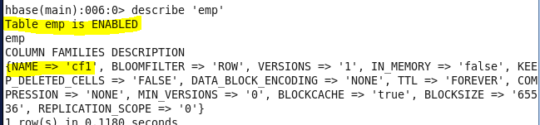

We cannot directly load path in the hbase_table_emp table and so another table is created with the same fields.

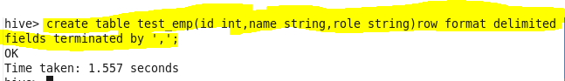

Loading data into table test_emp

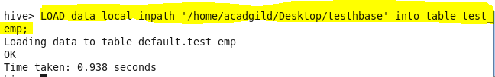

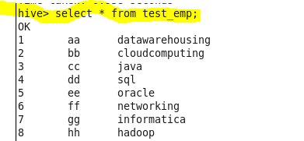

Insert data into hbase_table_emp from test_emp

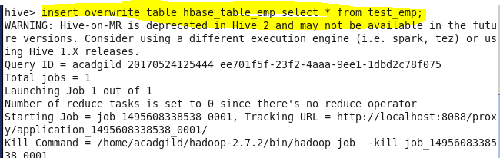

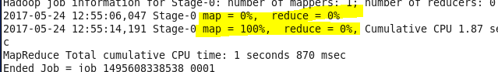

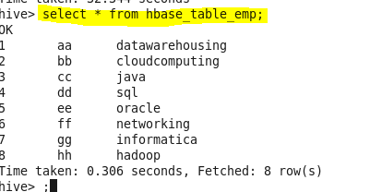

The same data is populated in hbase table (emp). It can be verified as follows:

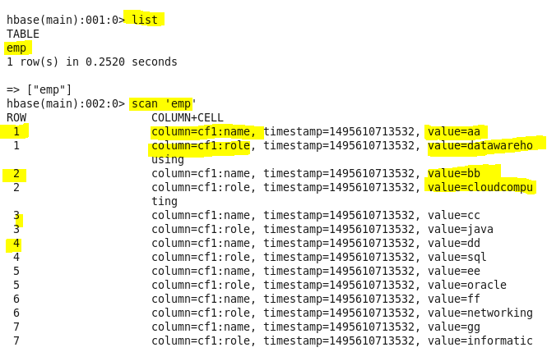

Therefore hive has been integrated with HBase successfully.